Assignment 3

Shuai

2023.02.26

# 1 Fundamental Matrix

Ex1:

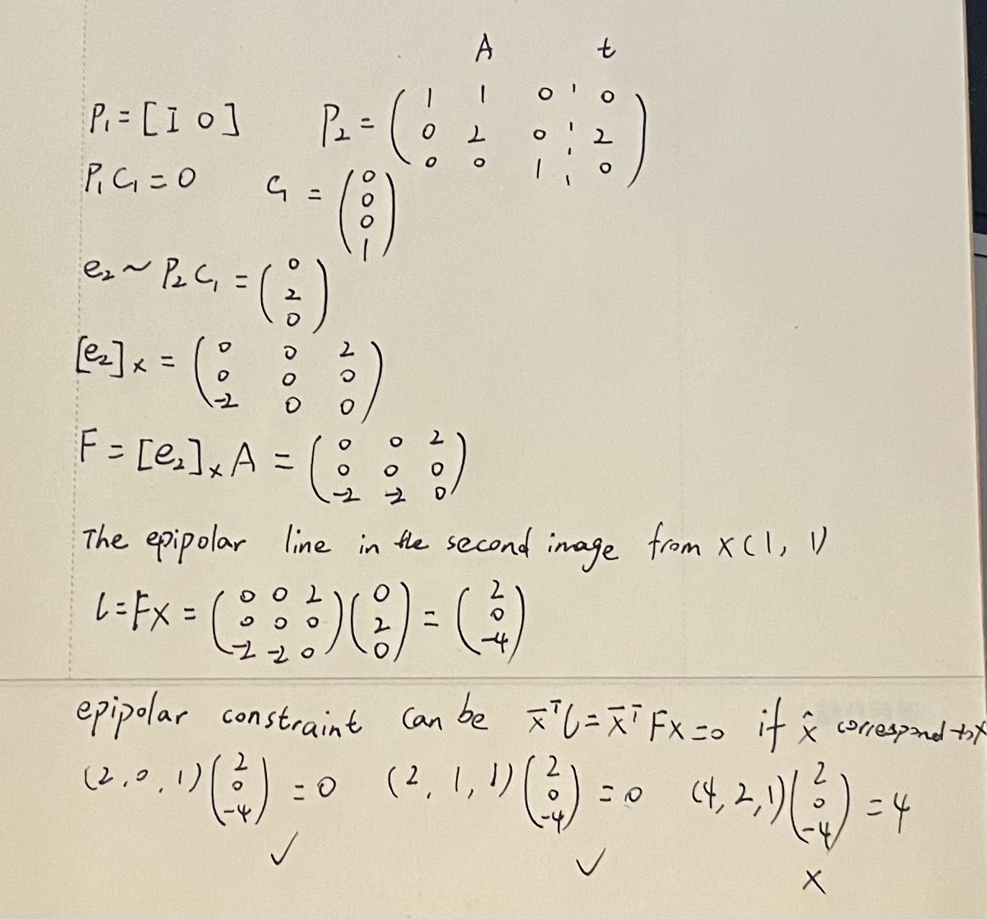

Figure 1 Ex1

Ex2:

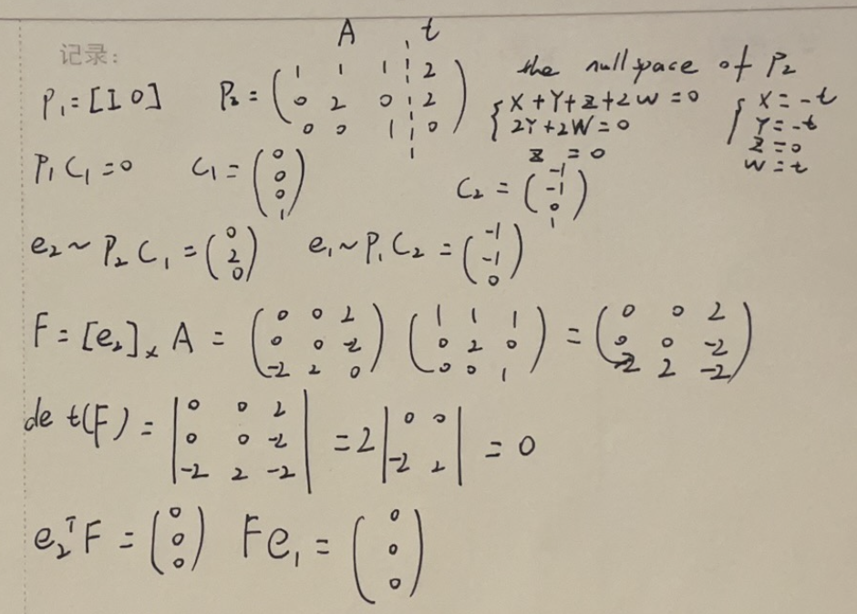

Figure 2 Ex2

OPTIONAL:

We know that the fundamental matrix relates corresponding points in the two views, and it is a rank 2 matrix since it is derived from the cross product of the camera matrices. Since the epipolar constraint eT2 F = 0 and Fe1 = 0 must hold for all corresponding points, the fundamental matrix F must have a nullspace that contains the epipoles e1 and e2. Since the dimension of the nullspace is at least 2, the determinant of F must be 0. This means that the fundamental matrix is singular and cannot be inverted.

Ex3:

$$F=N_{2}^{T}\tilde{F}N_{1}$$

CE1:

The fundamental matrix for the original (un-normalized) points (where F (3, 3) = 1, use F = F./F (3, 3))

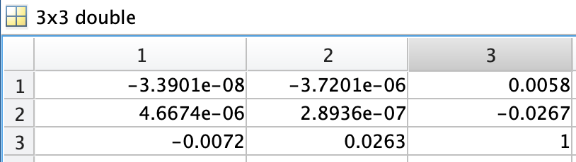

Figure 3 The fundamental matrix

The mean epipolar distances when F is computed both with normalization is 0.3612.

The mean epipolar distances when F is computed both without normalization is 0.4878.

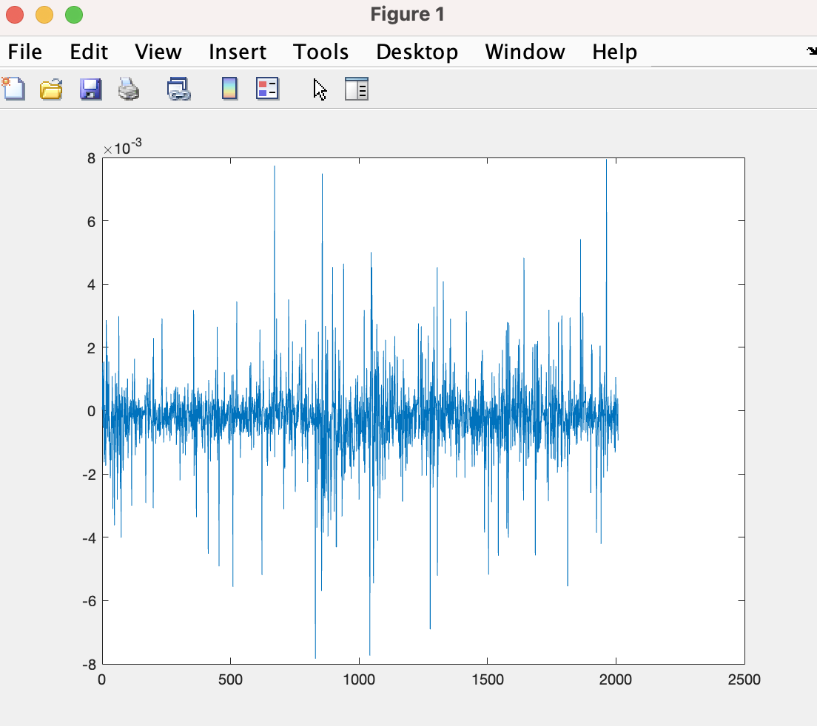

Figure 4 Epipolar constraints

The histogram and the plot of the epipolar lines are figure 5 and 6.

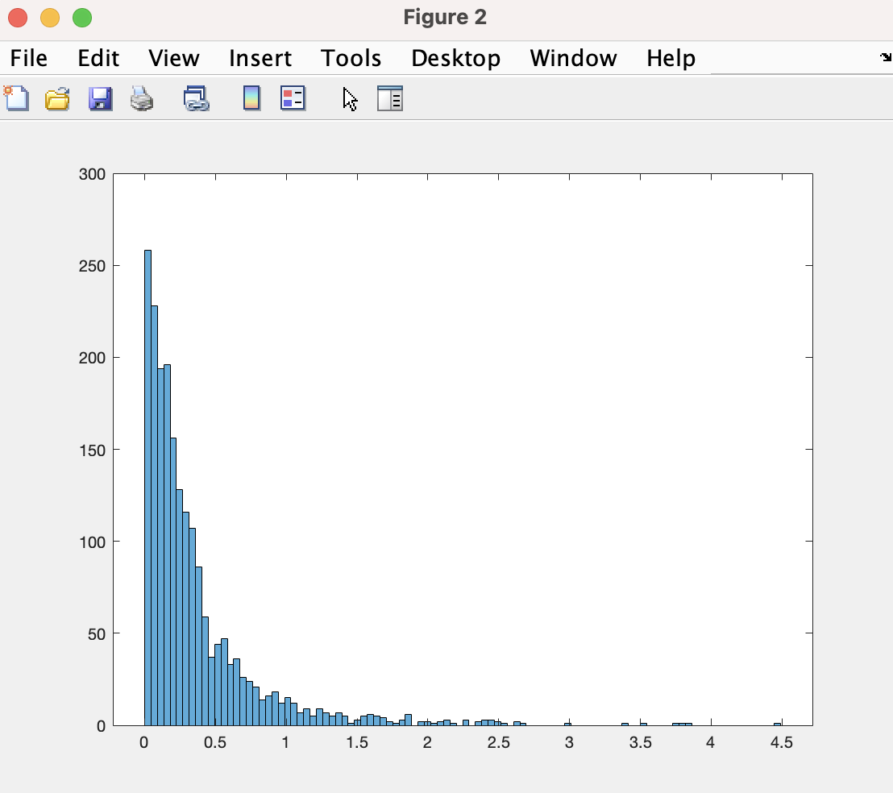

Figure 5 Histogram

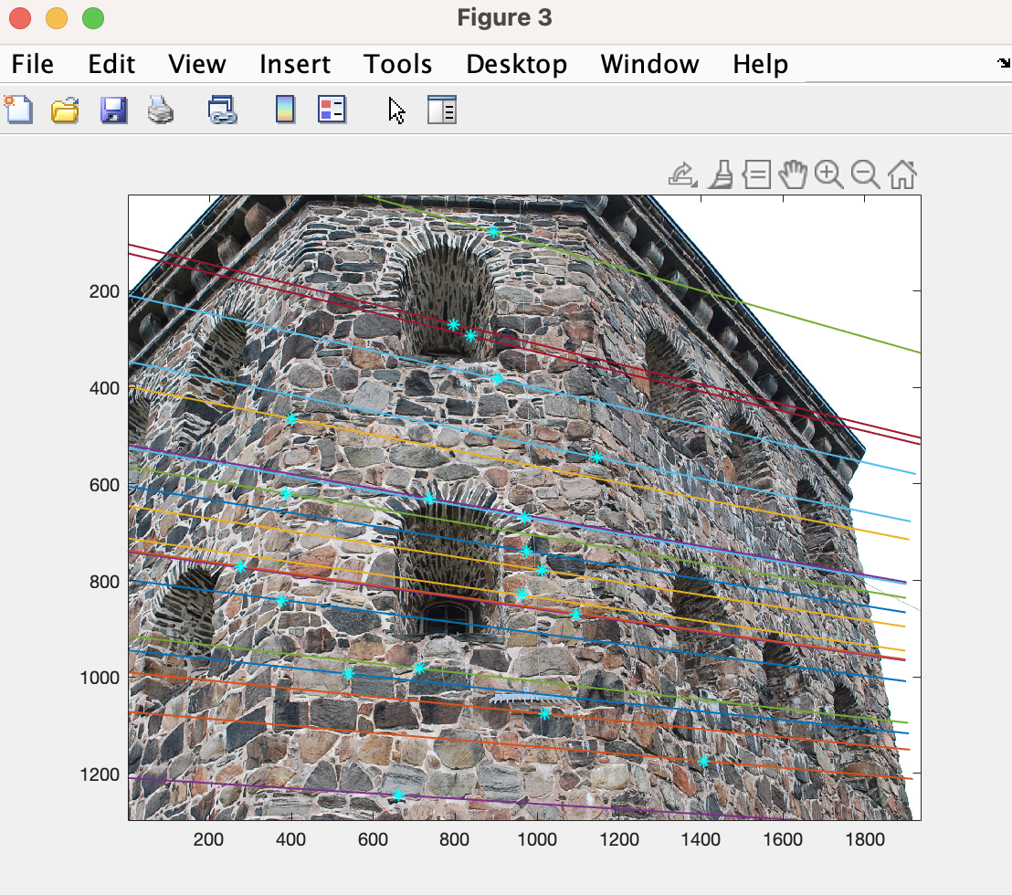

Figure 6 Random points and epipolar lines

Ex4:

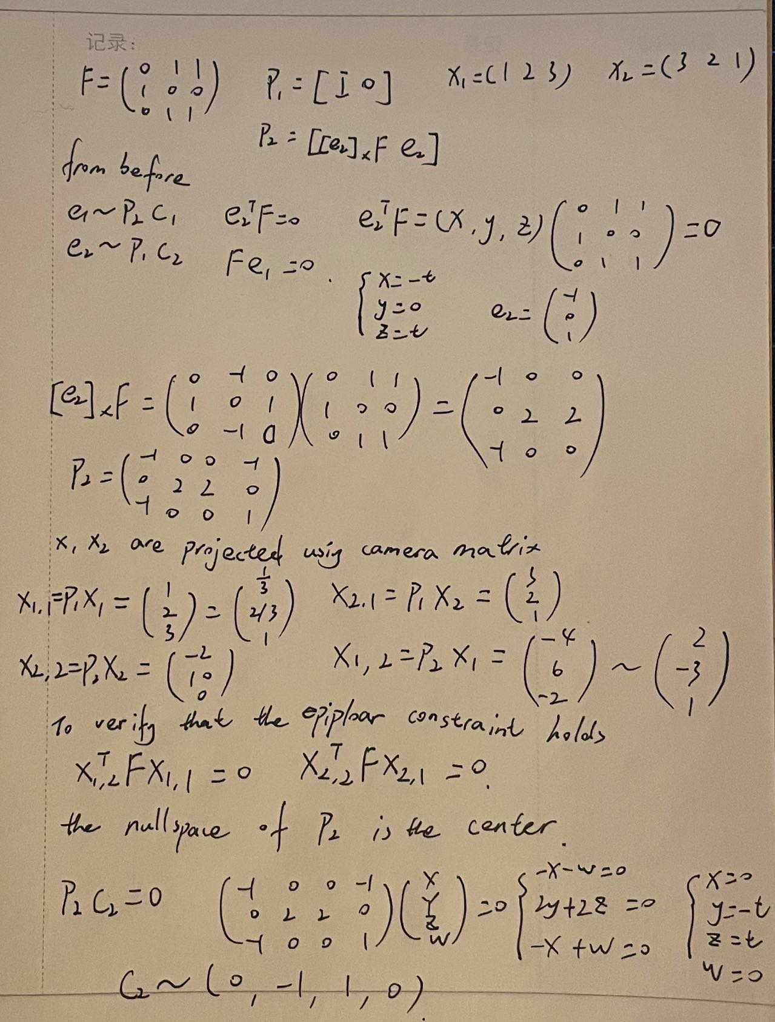

CE2:

The cameras matrices are P1 and P2

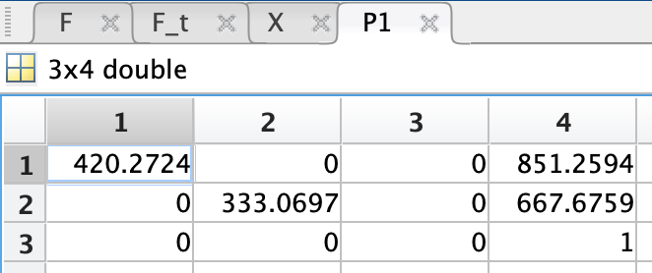

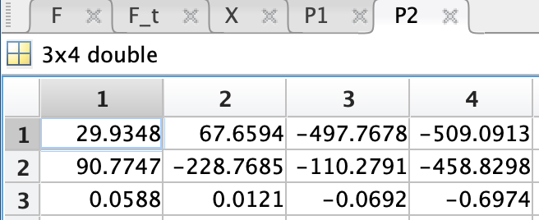

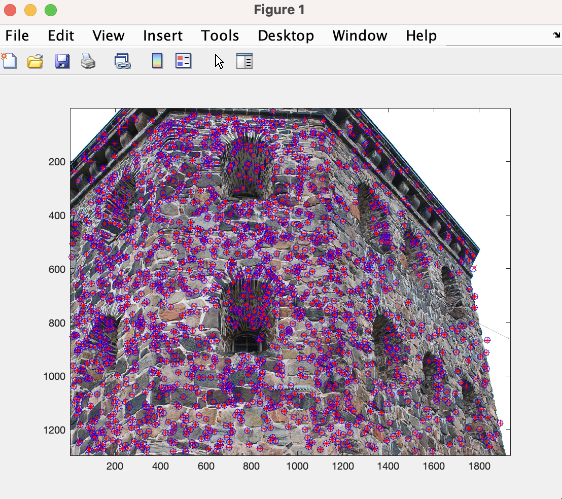

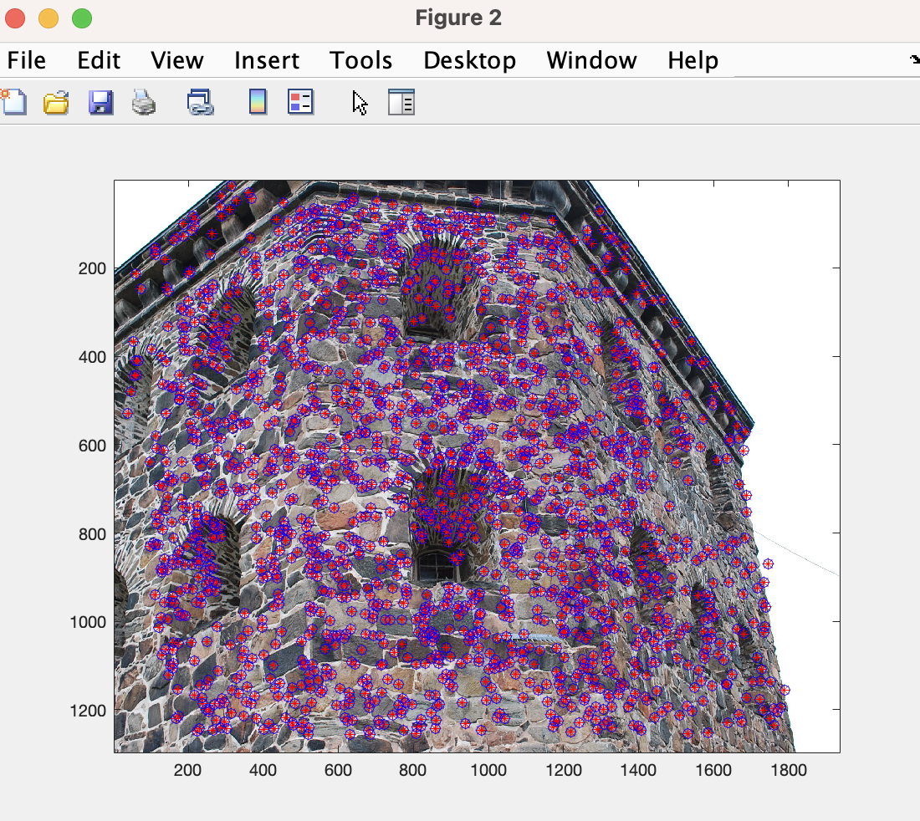

Figure 7 2D plot Red * are projection Blue are correct

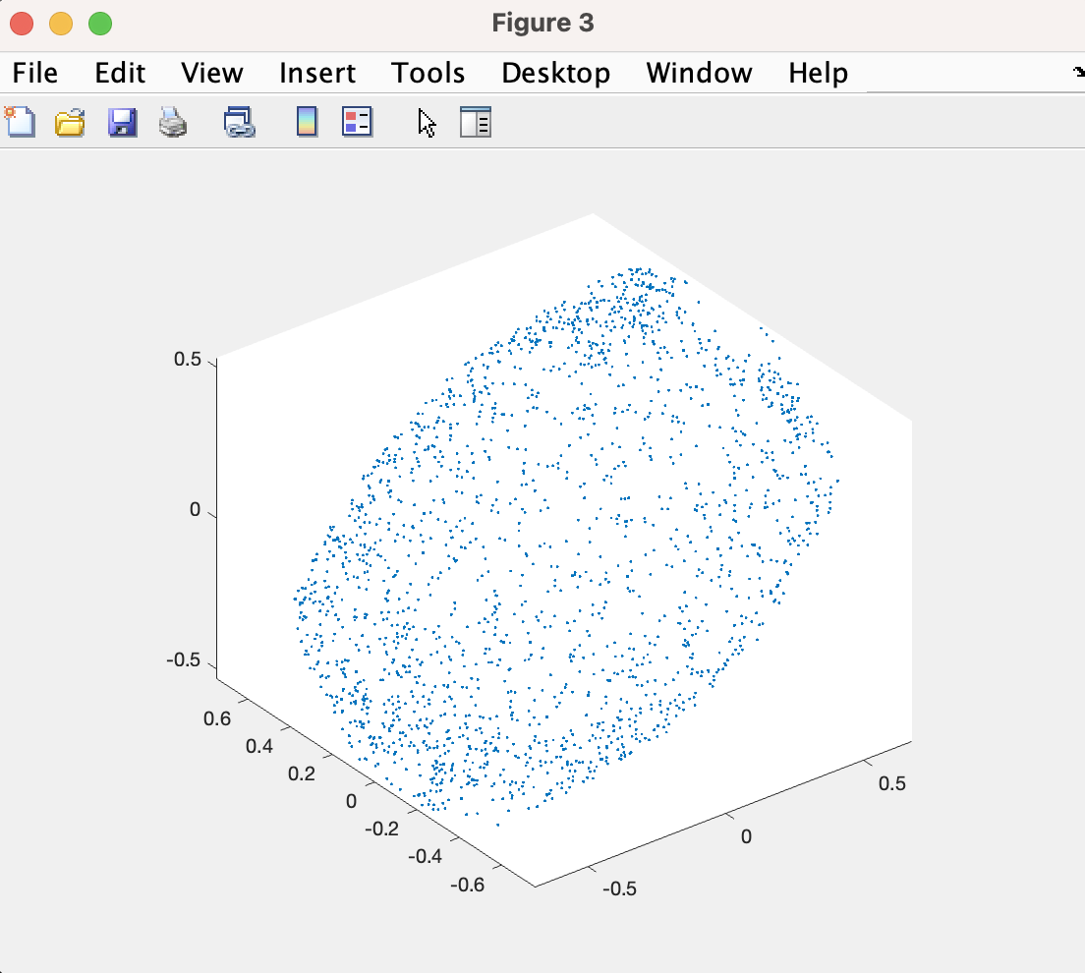

Figure 8

# 2 The Essential Matrix

Ex5:

To show that the eigenvalues of [t]T×[t]× are the squared singular values, we can use the fact that [t]T×[t]× = VT ST SU T USV, where ST S is diagonal with the singular values squared on the diagonal. Thus, the eigenvalues of [t]T×[t]× are the diagonal elements of ST S, which are the singular values squared.

To verify equation (5), we first expand the left-hand side using the identity in equation (6):

−t × (t × w) = (t · w)t − (t · t)w = ||t||^2w − (t · t)w = (||t||^2 − ||t||^2)w = 0w

Thus, we have shown that w = t is an eigenvector of [t]T×[t]× with eigenvalue 0.

Next, we consider a vector w that is perpendicular to t. We have:

[t]T×[t]×w = (t × (t × w))× = (t · w)t − ||t||^2w

Using equation (5) again, we see that this expression is equal to λw, where λ = ||t||^2. Thus, any vector w perpendicular to t is an eigenvector of [t]T×[t]× with eigenvalue ||t||^2.

Since [t]T×[t]× is a 3x3 matrix, we have found all three of its eigenvectors and corresponding eigenvalues.

To show that the singular values of [t]× are 0, ||t|| and ||t||, we first note that [t]× is skew-symmetric, which implies that its eigenvalues are purely imaginary or 0. We also know that the determinant of [t]× is 0, which means that it has at least one eigenvalue of 0. Therefore, [t]× has two purely imaginary eigenvalues, which are equal in magnitude and opposite in sign, and one eigenvalue of 0. The magnitude of the purely imaginary eigenvalues is equal to the norm of t, so the singular values of [t]× are 0, ||t|| and ||t||.

Finally, if E = [t]×R and [t]× has the SVD in (4), then we can write E = U'SV'T, where U' = [t]×U and V' = RV. The singular values of E are the same as the singular values of [t]×, which are 0, ||t|| and ||t||.

CE3:

The Essential matrix is

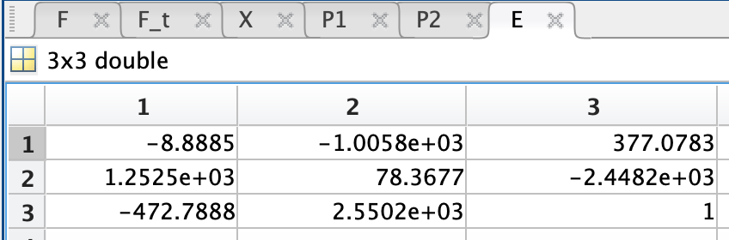

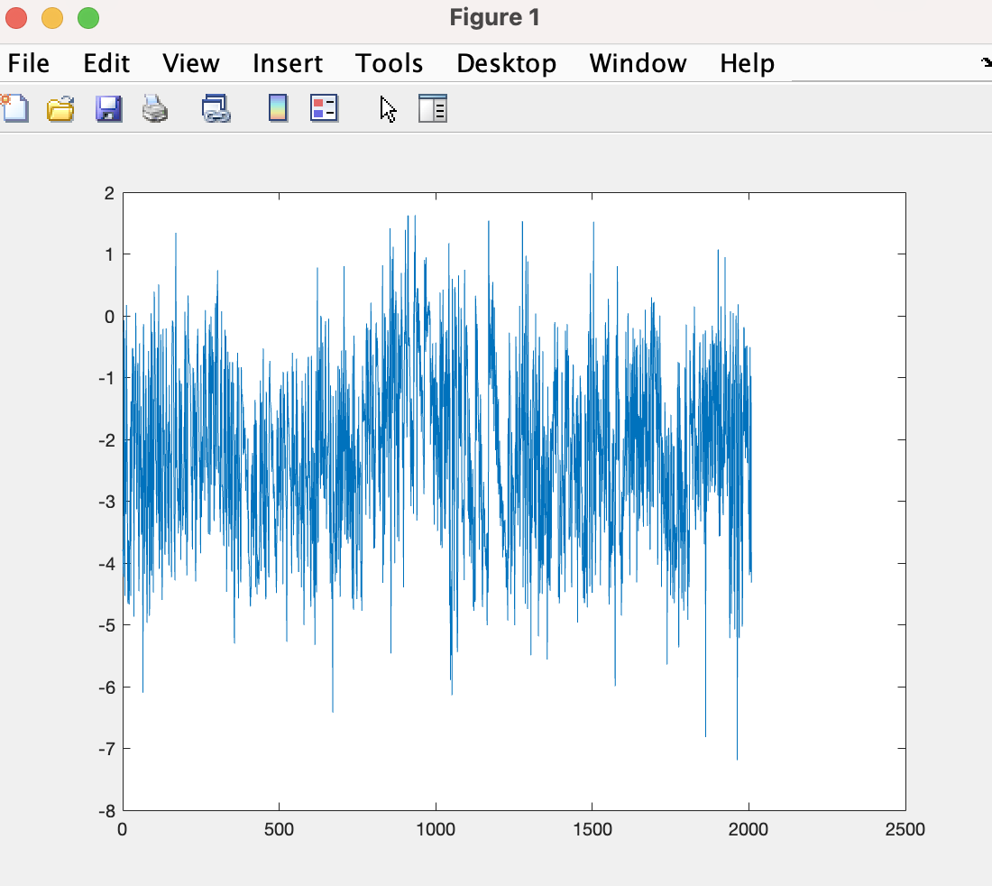

Figure 9 Errors of epiploar constraint

Figure 10 is the plot of the epipolar lines.

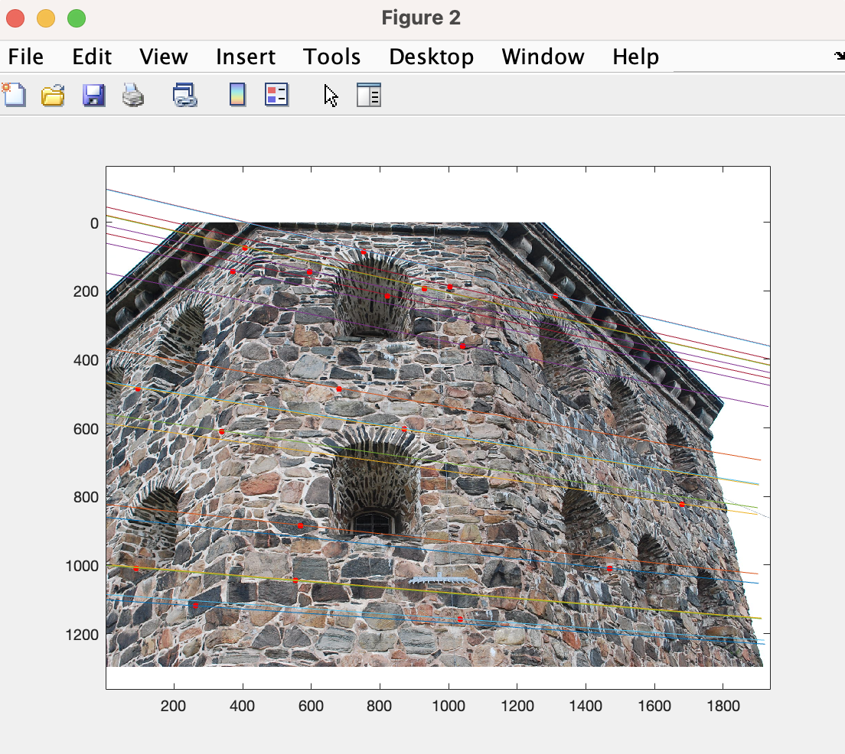

Figure 10 The epipolar lines

Figure 11 is the histogram of distances between points and lines.

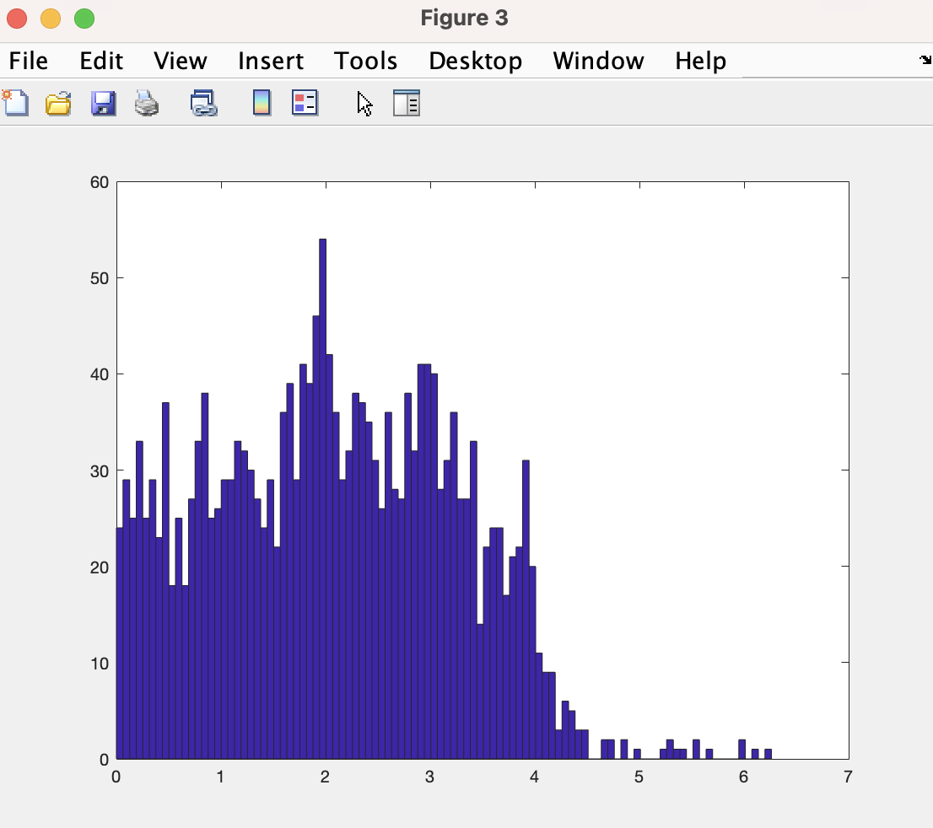

Figure 11 The histogram

Ex6:

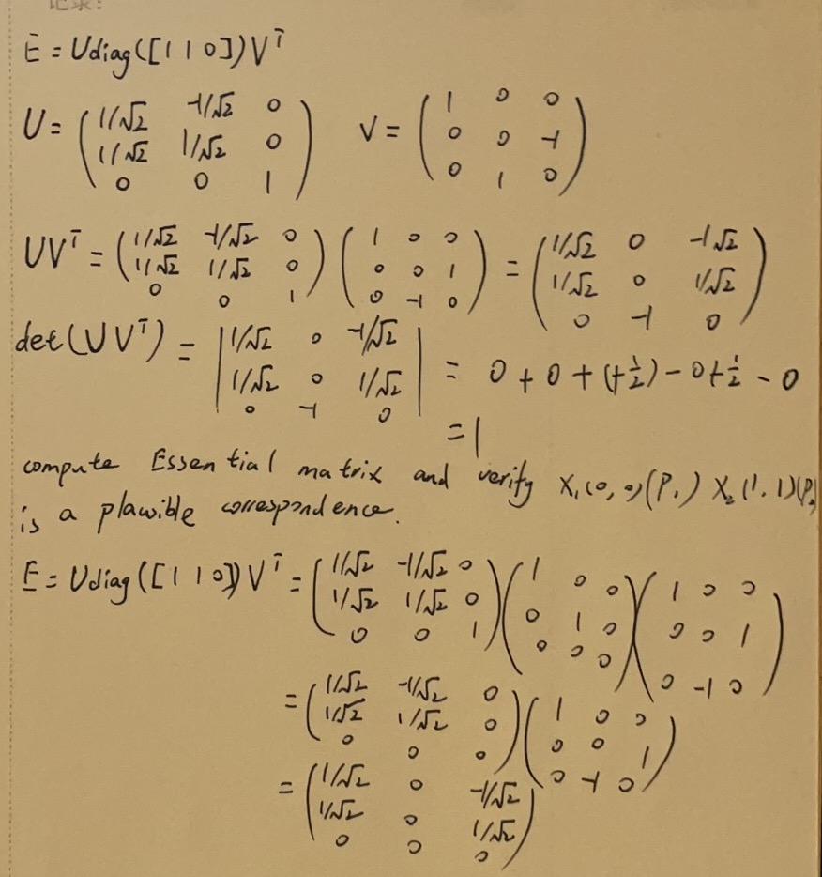

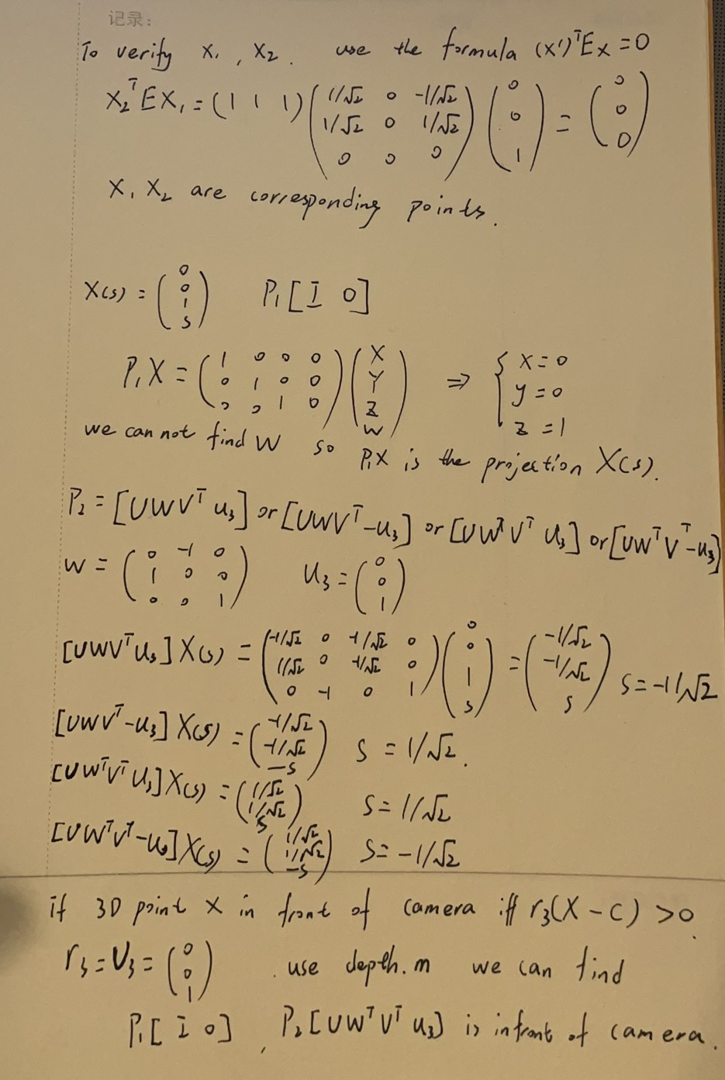z

Both cameras and depths should be positive.



CE4:

I plot the image the points and the projected 3D-points in the same figure. The errors look small.

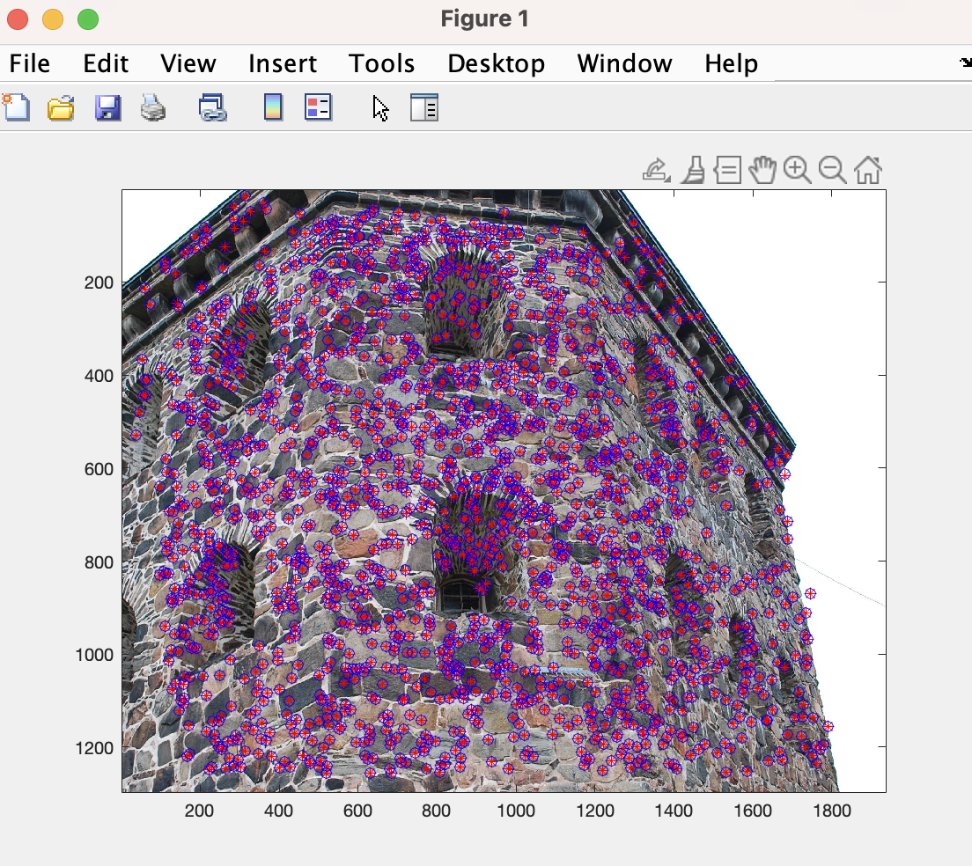

Figure 12

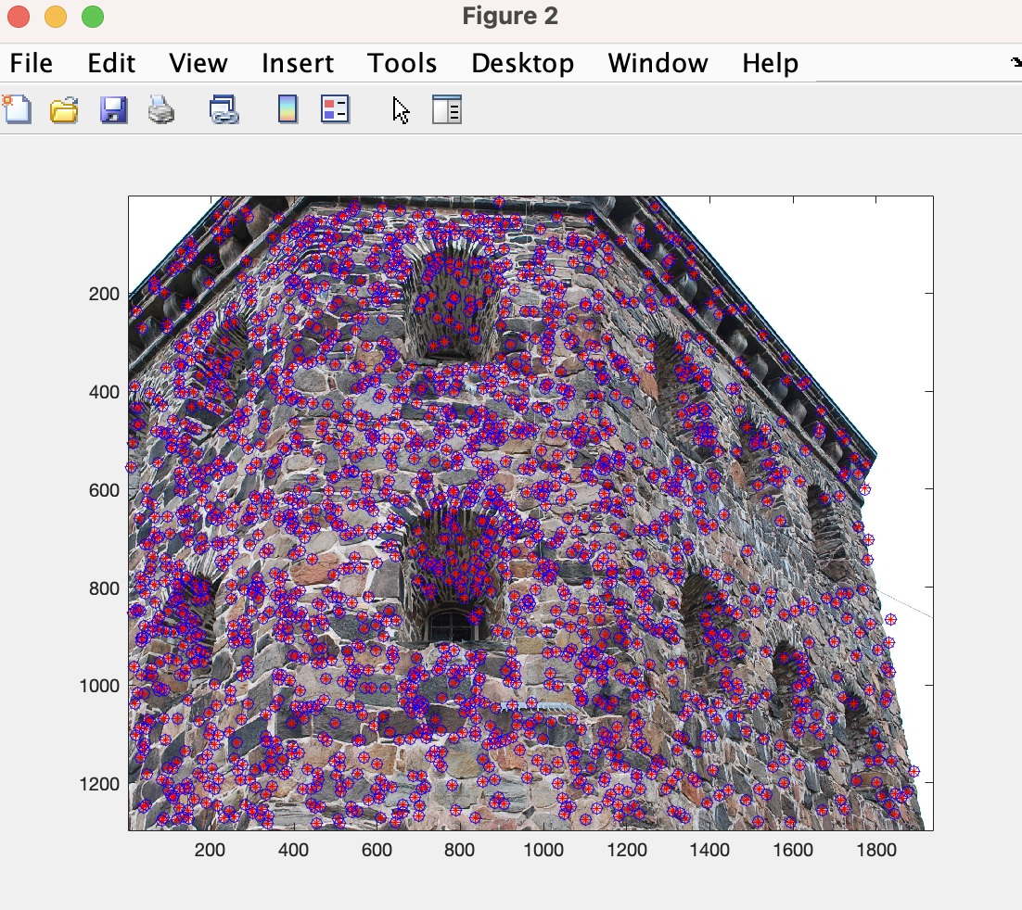

Figure 13

Figure 14 is 3D plot of the triangulated points. It looks like what I expected it to.

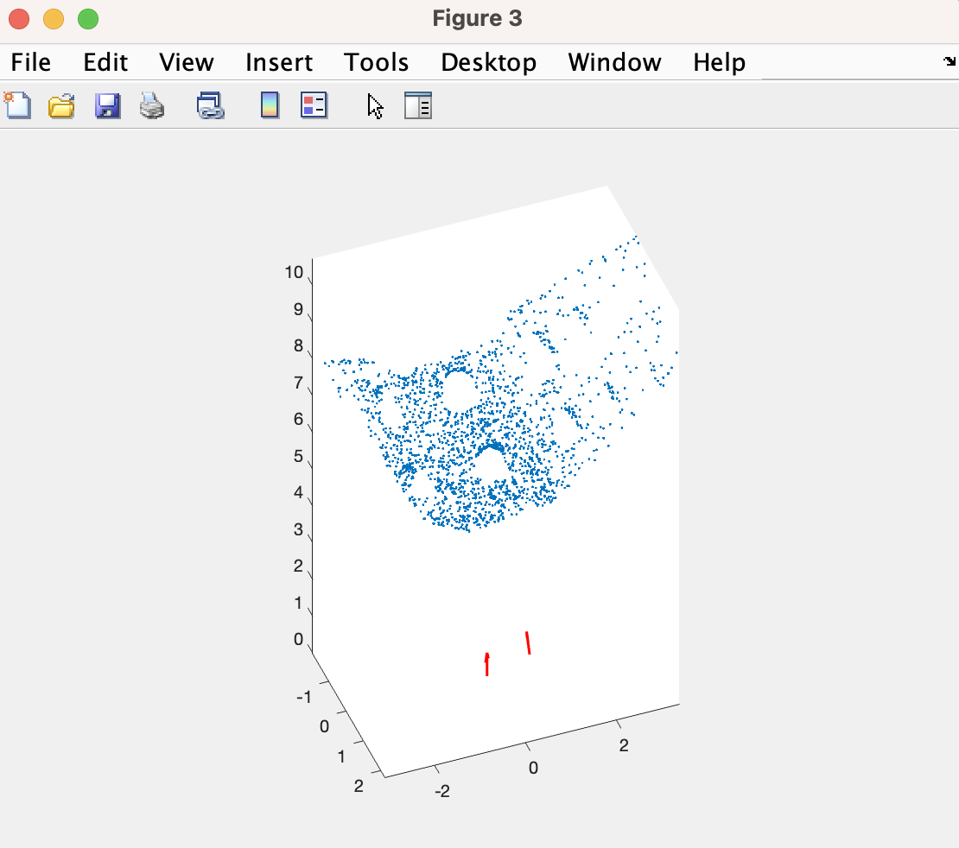

Figure 14 3D plot of the triangulated points